
APPLICATION BLANK

Thank you for the interest shown in Cinntra InfoTech. Please take a few minutes of your time to fill in the following details to help us understand your technical skills and personal competencies better.
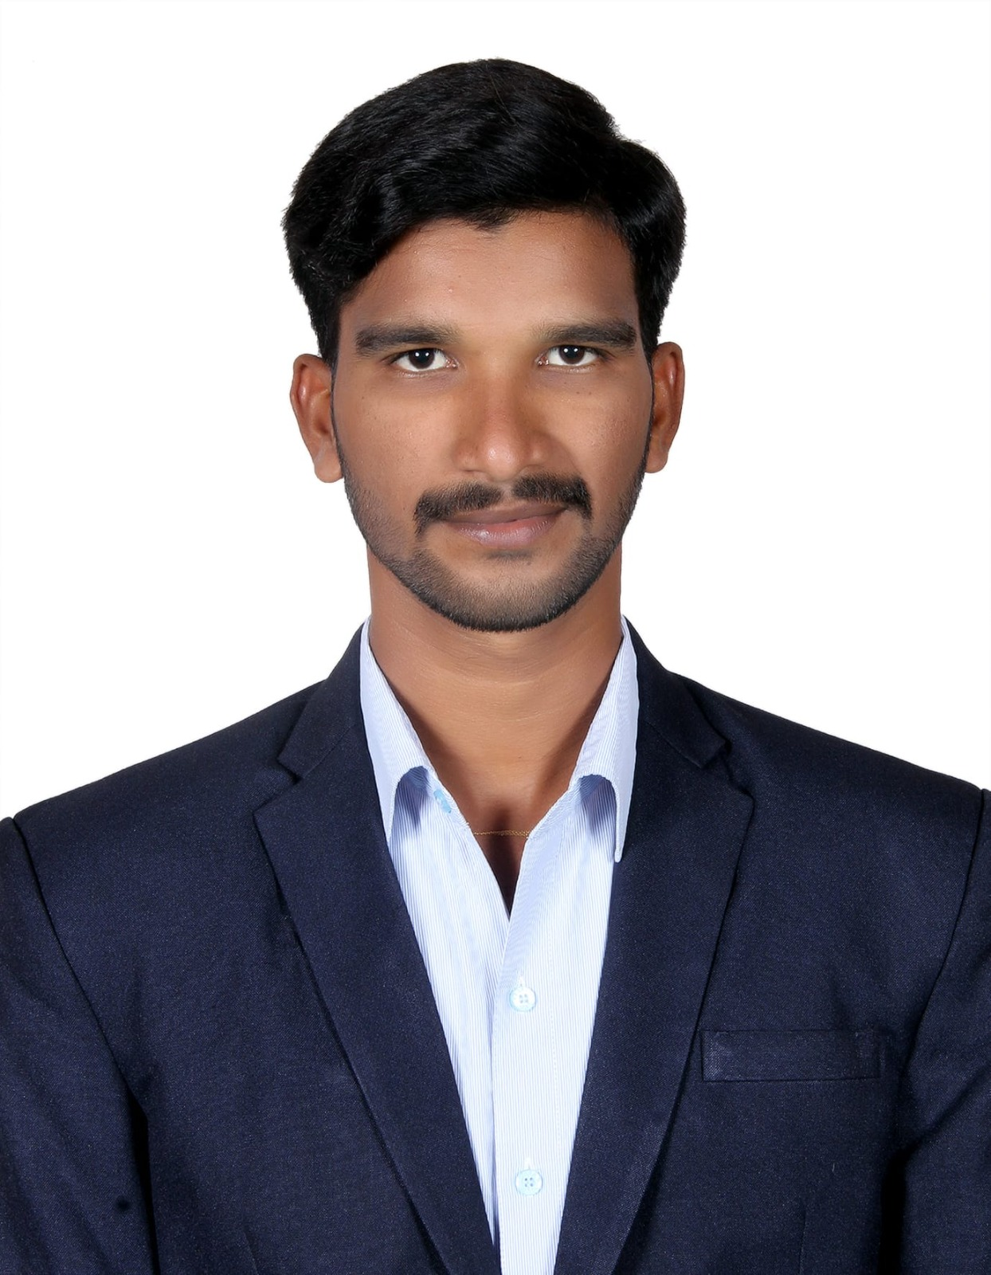
Please keep in mind the following when filling up the form:

- Fill in the boxes in the application blank in bold capital
letters unless the content is of a descriptive nature.

- Fill in the details according to the format mentioned
for the date and day.

NAME (As in Passport) |  | _______________SadhuSundarSingh___________/___Sodadasi__________________________________  Given Name Surname
Former Name (s) / Maiden Name (if applicable)
Father’s Name: ManikyalaRao
Nationality: Indian |  |  | Social Security Number (if applicable): N/A
Sex: Male |  |  | Marital Status: Single
Date of Birth: _____02______/__06_____/_1996_________  DD MM YY |  |  |  | Place of Birth:
ADDRESS | Present Address |  |  |  | Permanent Address
House No | #16, 5th Cross, PR Layout |  |  |  | 1-22, Chinapulleru, West Godavari
Locality / City | Marathahalli, Bangalore |  |  |  | Bhimavaram, Andhra Pradesh
State | Karnataka |  |  |  | Andhra Pradesh
PIN CODE | 560037 |  |  |  | 534237
Period of Stay | 2018 – Till Now |  |  |  | 1996
 (Telephone)
 (Mobile Phone) | 9676176785 |  |  |  | 9866712666
E-mail ID (Personal) | sadhusunsin@gmail.com |  |  |  | 2
Instant Messaging System ID:

Passport Details: |  | Available |  | Not Available |  | Applied
Number | : 7731999299
Date Of Issue | : 30/07/2018
Date of Expiry | : 29/07/2028
Place Issue | : Visakhapatnam
 |  |  |  |  |  |  | Yes |  | No
Do you have a valid Car Driving License |  |  |  |  |  |  |  |  | No
Have you had any visa rejections? If yes, please mention the nature of visa & reason for rejection. |  |  |  |  |  |  |  |  | No
Are you open to Travel to the USA / Sri Lanka on work for a period of 6 mths/less during a year? |  |  |  |  |  |  |  |  | No

S.No | Languages Known | Read | Write | Speak
1 | English | Yes | Yes | Yes
2 | Telugu | Yes | Yes | Yes
3 | Kannada | Yes | No | Yes
4
Family Information (Parents, Brothers, Sisters, Spouse & Children)
S.No | Name | Relationship | Date of Birth | Age
1 | ManikyalaRao | Father | 1960 | 63
2 | Sundaramma | Mother | 1965 | 58
3
4
5

EDUCATION INFORMATION
Degree | Course | Program (full-time/Part-time) | Elective | College Name and Address | University Name and Address | Duration |  | % | Graduation Date (MM/YY)
X | SSC | Full Time |  | ZP High School, Seesali | Board Of Secondary Education | 2010 | 2011 | 73 | 2011-June
XII | CEC | Full Time |  | Kasturba Jr College | Board Of Intermediate | 2011 | 2013 | 63 | 2013 - June
Graduation | B.Com  (Comp) | Full Time |  | DNR College | AKNU University | 2013 | 2016 | 80 | 2016 - June
PG | MBA | Full Time |  | DNR SB Management | JNTUK University | 2016 | 2018 | 63 | 2018 - May
Others 1

SSN No. (mandatory if studied in USA or Canada):

* Please mention the last full time degree

ADDITIONAL QUALIFICATIONS/ DIPLOMAS / CERTIFICATES / TRAINING
Please mention any Self learned course /Software /Package)
Program | Institute | Duration |  | % | Division
 |  | From | To

SEMINARS / TRAINING PROGRAMS ATTENDED
S.No | Seminar / Training Program | Conducted by | Duration
S.No | Seminar / Training Program | Conducted by | From | To
1
2
3

MAJOR ACHIEVEMENTS /PUBLICATIONS TO YOUR CREDIT
S.No |  |  |  | Description |  |  |  |  |  |  |  |  | Year
1
2

PROJECT INFORMATION (In ascending order give details of the recent projects)
S.No |  | Title |  |  | Company |  | Client | Platform and Skills used |  | Team Size | Role
1 |  | DevOps Deploymentation In |  |  | FSS |  | Capgemini | AWS, DevOps |  | 18 | DevOps Engineer
2 |  | Cloud Migration |  |  | FSS |  | Capgemini | AWS, DevOps |  | 30 | DevOps Engineer
3
Please name two known contacts who could be friends / co-workers whom you would like to
recommend for Employment at Cinntra InfoTech
 |  |  | Name |  |  | Current Company |  |  | E-mail address |  |  | Contact Number
 | 1 |  | Anil |  |  | Archwell Operation India pvt ltd |  |  | Vanilkumar0990@gmail.com |  |  | 9676176788
 | 2 |  | Balaji |  |  | Infosys pvt ltd. |  |  | Balaji0213@gmail.com |  |  | 7674032414

Details of Previous Employers (Starting from your Current Job, covering up to Last 3 Employments)

Please attach a copy of your relieving letter/service certificate for this
Company Name (1): Florida Software Solutions |  | Last Designation held: DevOps Engineer
Address (main office and branch where worked): No. 334, 27th, Main Road, 2nd Sector, HSR Layout, Bangalore-560102 |  | Telephone: 080-4681-0886
Employment Period: (date, month, year)  From: 23/10/2018 To: 24/03/2023 | Employee Code/ Personnel No: |  | Name of Reporting Manager
Name of HR: Aravind | Contact No. of HR: 080-4681-0886 |  | Email Id of HR: aravind.k@floridaug.com
Designation & Department of Reporting Manager | Contact No of Reporting Manager: |  | Email ID of Reporting Manager:
Name of Alternative Reporting Manager:  Mohan Nayak  Designation & Department of Alternative Reporting Manager:  Mohan Nayak | Contact No of Alternative Reporting Manager:  : 080-4681-0886  Email ID of Alternative Reporting Manager:  Mohan.n@floridaug.com
Whether employment is of permanent or temporary nature - ◻ Permanent ◻ Temporary

Agency Details (if temporary or contractual): Permanent

Remunerations (CTC pa): 7 LPA | Reason(s) for Leaving: Looking For Good Opportunity

Details of Previous Employers (Starting from your Current Job, covering up to Last 3 Employments)

Please attach a copy of your relieving letter/service certificate for this
Company Name (2) : |  |  | Last Designation held:
Address (main office and branch where worked): |  |  | Telephone:
Employment Period: (date, month, year)  From To | Employee Code/ Personnel No: |  |  | Name of Reporting Manager
Name of HR: | Contact No. of HR: |  |  | Email Id of HR:
Designation & Department of Reporting Manager | Contact No of Reporting Manager: |  |  | Email ID of Reporting Manager:
Name of Alternative Reporting Manager  Designation & Department of Alternative Reporting Manager | Contact No of Alternative Reporting Manager:  Email ID of Alternative Reporting Manager:
Whether employment is of permanent or temporary nature - ◻ Permanent ◻ Temporary
Agency Details (if temporary or contractual)

Remunerations (CTC pa) |  | Reason(s) for Leaving

Details of Previous Employers (Starting from your Current Job, covering up to Last 3 Employments)

Please attach a copy of your relieving letter/service certificate for this
Company Name (3) : |  |  | Last Designation held:
Address (main office and branch where worked): |  |  | Telephone:
Employment Period: (date, month, year)  From To | Employee Code/ Personnel No: |  |  | Name of Reporting Manager
Name of HR: | Contact No. of HR: |  |  | Email Id of HR:
Designation & Department of Reporting Manager | Contact No of Reporting Manager: |  |  | Email ID of Reporting Manager:
Name of Alternative Reporting Manager  Designation & Department of Alternative Reporting Manager | Contact No of Alternative Reporting Manager:  Email ID of Alternative Reporting Manager:
Whether employment is of permanent or temporary nature - ◻ Permanent ◻ Temporary

Agency Details (if temporary or contractual):

Remunerations (CTC pa): |  | Reason(s) for Leaving

Please account for any and all gaps in education or employment during your tenure.

From | To | Reason: | Complete Address and Location
From | To | Reason: | Complete Address and Location
From | To | Reason: | Complete Address and Location

Organization Chart showing your current position in the current assignment
Key responsibilities at current assignment: I am responsible to setup and manage CICD DevOps Pipelines using various tools like Git, GitHub, Jenkins, Ansible, Docker and Kubernetes etc.
We can Automate Build and Deployment process.
Managing Git Branches.
Ensuring Back and creating Backup also.
Managing user access On resources.

PERSONAL ASSESMENT
Please put down in five succinct points as what you consider your strengths and Weaknesses.
STRENGTHS | 1 | Quick learning and adaptivety to new environment
STRENGTHS | 2
STRENGTHS | 3
STRENGTHS | 4
STRENGTHS | 5
WEAKNESSES | 1 | I am a self-learner and try to achieve tasks without any help could lead some delay in tasks.
WEAKNESSES | 2
WEAKNESSES | 3
WEAKNESSES | 4
WEAKNESSES | 5

REFEREES - Please give two references of which one should necessarily be from your Present
Work Place.
Name & Designation | Current Company | Address | Contact Details | No of Mths /  Yrs Of Acquaintance

* In case your previous employer has closed operations please mention and provide above names and contact details of your supervisors in the above fields..
Which Sport /Hobby / Activity provides you immense satisfaction? State briefly as to why?
Reading Books: Reading books is great way to expand our knowledge.
Playing Cricket and Volleyball: sports can be a great way to stay active and social.

What are your short team goals?
My Short time goal is to get a job in reputed company where I can utilize my skills and improve my carrier
Path.

What are your long term goals?
My long term goal is to be in respectable position in that organization.

Have you ever attended an interview at any of the Cinntra InfoTech Offices across the Globe in the last 6 months? Yes/No (If yes, mention the details): No

Declaration and Authorization

I understand that any employment by Cinntra InfoTech Solutions Private Limited or its affiliated companies is conditioned upon positive responses from my references, bonding eligibility, continued adherence to Cinntra InfoTech Solutions Private Limited policies and procedures, applicable rules and regulations and job performance satisfactory at all times to Cinntra InfoTech Solutions Private Limited.

I consent to take any pre or post-employment examinations as may be required by Cinntra InfoTech Solutions Private Limited or its permitted agents, its representative, and release Cinntra InfoTech Solutions Private Limited and its agents from any liability that may arise from such examination.

I authorize an inquiry to be made on the information contained on this application. Former employers and officials of education institutes, named on this application are authorized to give information about me and I release them from all liability for issuing such information.

I hereby attest and warrant that all my answers on this application as well as on all forms completed in conjunction with my employment are true and accurate. I understand that my misrepresentation of facts, failure to disclose information required on this application or material change in my information provided which is not reported to Human Resources shall be cause for dismissal regardless of when discovered by Cinntra InfoTech Solutions Private Limited

I understand, and authorize, that Cinntra InfoTech may share my consumer report and/or investigative report with third parties including auditors, government agencies, and clients as necessary.

I hereby declare that the information given by me is true and the certificates or documents submitted are genuine to the best of my knowledge.

Signed: _____s.s.s.singh___________________

Name in Block Capitals: _______SODADASI SADHU SUNDAR SINGH_________________

Date: ______22-03-2013__________________

